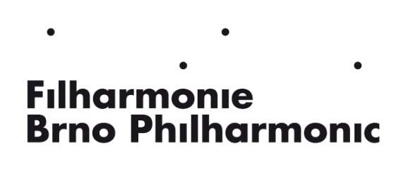

The Managing Director of the Brno Philharmonic Orchestra

invites applications for

The position of second violin tutti

The auditions are taking place in the Concert Hall of Besední dům, Komenského náměstí 8, Brno, Czech Republic, at 13 p.m. on March 3rd, 2025.

AUDITION REQUIREMENTS:

1st Round:

W. A. Mozart:​ first movement of a concerto with cadenza

Orchestral excerpts: ​ W. A. Mozart:​​ Symphony No. 39 in E flat major
B. Smetana: Overture Bartered Bride
B. Smetana: Šárka (My Country)

2nd Round:

1st or 2nd and 3rd movements from violin concerto – romanticism, 20th century

Orchestral excerpts: ​ L. van Beethoven: Symphony No. 9
B. Smetana: Vyšehrad (My Country)
A. Dvořák: Carnival
R. Strauss: Don Quixote
L. Janáček: Taras Bulba
L. Janáček: Glagolitic Mass

Written applications with CV, contact details, information about the applicant’s education (a diploma from a conservatory or a music academy or university, at least secondary school-leaving certificate to be submitted by the start of the contract) and overview of previous artistic experience are due on February 3rd, 2025 at the following address:

Filharmonie Brno, p.o., Komenského náměstí 534/8, 602 00 BRNO, Czech Republic
or at the following e-mail address: alena.albiniova@filharmonie-brno.cz., (phone +420 539 092 837).

Please note in your application if you will require piano accompaniment. After the closing date for applications (February 3rd, 2025) and upon the applicant´s request the parts can be sent to invited participants available at the Brno Philharmonic archive (vojtech.linhart@filharmonie-brno.cz, tel. 539 092 848). They can also be downloaded at www.filharmonie-brno.cz.

The first round is screened/anonymous.

Expected start of the contract: 1. 9. 2025

In Brno on 3.12.2024

PhDr. Marie Kučerová
managing Director of the Brno Philharmonic Orchestra

